Adjustable Bed Raiser Unit  LLR3 (NLP129, NLP129S)    As with all devices designed to assist the elderly or disabled, care should be taken to avoid sudden or undue movement, when using this equipment.  - Position units on the floor parallel to the front and rear of bed.  - Loosen wingnuts and adjust to size so that bed castors will drop into raiser sockets. Plastic blocks for insertion into raisers are supplied with each unit. Two blocks are supplied (to raise from 24-mm to 48-mm) therefore it is important to check that the extra height being added is the same for all four raisers.  - Lift bed and place legs into sockets. Ensure the rails run side to side under the bed, so as not to present a trip hazard to the user.  - Push raiser sockets tight up against the corners of the legs.  - Tighten the wingnuts.  - Ensure bed is stable on the raisers before use.  - For very heavy or cumbersome beds a Bed Jack would provide useful assistance.  - This product is designed for use in a loaded static mode only.  Maximum operating weight  500-kg (Including weight of bed) | 
 | 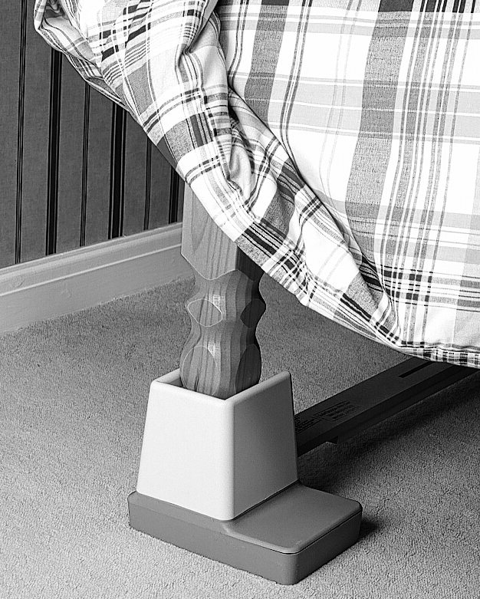
 | NLP129/0401

